WEEK 3 INTERNSHIP TASK
Feature Engineering and Model Building
Project: Telco Customer Churn
Submitted by: K. Avinash
Program: BTech Computer Science and Engineering
Domain: Data Analytics and Machine Learning
Week: 3
Internship Name: - Virtual Data Science Apprentice Intern
Executive Summary
This Week 3 internship task applied feature engineering and supervised machine learning to the Telco Customer Churn dataset. The project used customer demographics, service subscriptions, contract details, payment information, tenure, and billing data to predict whether a customer would churn. The target variable was Churn, represented as 1 for a churned customer and 0 for a customer who remained with the company.
After revisiting the cleaned dataset, seven new features were created to represent customer engagement, spending, payment behaviour, and contract flexibility. Logistic Regression was trained as an interpretable baseline model, and a Decision Tree Classifier was trained to capture non-linear decision patterns and provide feature-importance information. Data was split into 80% training data and 20% testing data with stratification by the target variable.
Logistic Regression achieved 79.91% accuracy and an ROC-AUC of 0.8412. The Decision Tree achieved 75.16% accuracy, but a higher churn recall of 76.20% and an F1-score of 61.96%. Because churn identification is the practical focus, the Decision Tree was selected as the more suitable operational model: it identifies more at-risk customers, although it generates more false-positive alerts. The most important feature for the Decision Tree was IsMonthToMonth, followed by tenure and fibre-optic internet service.
1. Problem Description and Objectives
Customer churn occurs when a customer stops using a company's service. For a telecommunications company, churn prediction is valuable because retaining an existing customer is often more cost-effective than acquiring a new one. The project investigates whether customer account, service, contract, and payment characteristics can be used to identify churn risk.
- Revisit and prepare the Telco Customer Churn dataset for predictive modelling.
- Create relevant features that represent customer engagement, spending, and contract behaviour.
- Develop an interpretable baseline model using Logistic Regression.
- Develop and compare a Decision Tree Classifier.
- Evaluate models using accuracy, precision, recall, F1-score, ROC-AUC, confusion matrices, and ROC curves.
- Interpret useful predictive patterns and suggest practical improvements for future model iterations.
2. Dataset Context and Data Preparation
The Telco Customer Churn dataset contains 7,043 customer records and 21 original columns. Each record represents one customer. The variables describe demographic details, service subscriptions, account details, contract type, billing information, and churn status. The dataset is appropriate for binary classification because Churn has two possible outcomes: Yes or No.
Dataset attribute | Description
Dataset | Telco Customer Churn dataset
Original size | 7,043 rows and 21 columns
Unit of analysis | One customer record per row
Target variable | Churn: customer left (1) or stayed (0)
Source URL | [USER MUST ADD: exact dataset source URL]
Notebook | Virtual_InternWeek3.ipynb

The data preparation reused the Week 1 cleaning approach. customerID was removed because it is a unique identifier rather than a behavioural predictor. TotalCharges was converted from text to float64 after blank strings were replaced with missing values. Blank TotalCharges values associated with zero-tenure customers were assigned 0, and any remaining unexpected missing values were handled with median imputation. Churn was encoded as 1 for Yes and 0 for No.
Code: -
df_model = df.drop(columns=["customerID"]).copy()
df_model["TotalCharges"] = pd.to_numeric(
df_model["TotalCharges"].replace(r"^\s*$", np.nan, regex=True),
errors="coerce"
)
df_model.loc[(df_model["tenure"] == 0) &
(df_model["TotalCharges"].isna()), "TotalCharges"] = 0
df_model["TotalCharges"] = df_model["TotalCharges"].fillna(
df_model["TotalCharges"].median()
)
df_model["Churn"] = df_model["Churn"].map({"Yes": 1, "No": 0})
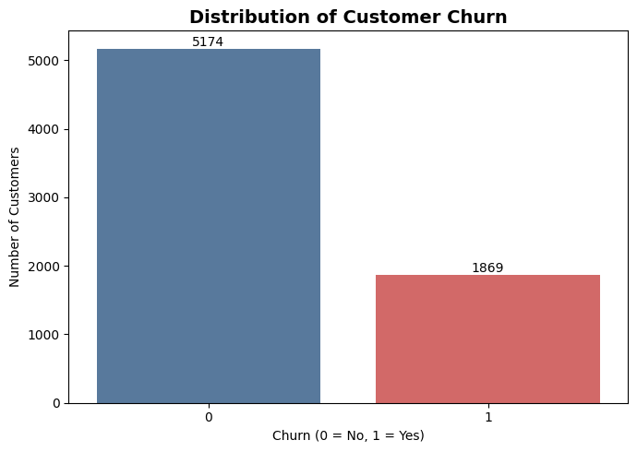

3. Feature Engineering Methodology
Feature engineering transforms existing information into additional variables that can make customer patterns easier for a model to learn. The following engineered features were developed from raw customer information. Each feature was selected because it has a clear business interpretation related to customer engagement, cost, loyalty, or contract flexibility.
Engineered feature | How it was created | Rationale
TotalServices | Count of services with a Yes subscription. | Customers using more services may be more engaged with the provider.
AvgMonthlySpend | TotalCharges divided by tenure; MonthlyCharges used when tenure is 0. | Represents approximate average monthly spending across the customer relationship.
TenureGroup | Tenure grouped into 0-12, 13-36, 37-60, and 61-72 months. | Makes customer lifecycle stages easier to compare.
HasPartnerOrDependents | 1 if Partner or Dependents equals Yes; otherwise 0. | Represents a household/family context that may relate to retention.
AutoPayment | 1 for automatic bank transfer or credit-card payment. | Tests whether automated billing is associated with retention behaviour.
IsMonthToMonth | 1 when Contract equals Month-to-month; otherwise 0. | Provides a direct indicator of flexible-contract churn risk.
ChargePerService | MonthlyCharges divided by TotalServices, using 1 when total services equals 0. | Represents approximate monthly cost per subscribed service.

Code : -
df_model["TotalServices"] = (
df_model[service_columns]
.apply(lambda col: (col == "Yes").astype(int))
.sum(axis=1)
)
df_model["AvgMonthlySpend"] = np.where(
df_model["tenure"] > 0,
df_model["TotalCharges"] / df_model["tenure"],
df_model["MonthlyCharges"]
)
df_model["IsMonthToMonth"] = (
df_model["Contract"] == "Month-to-month"
).astype(int)

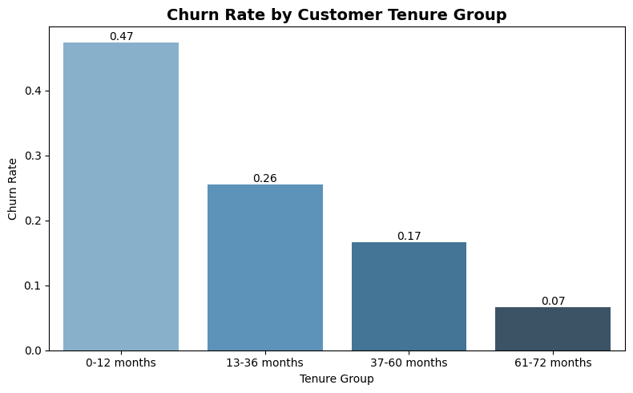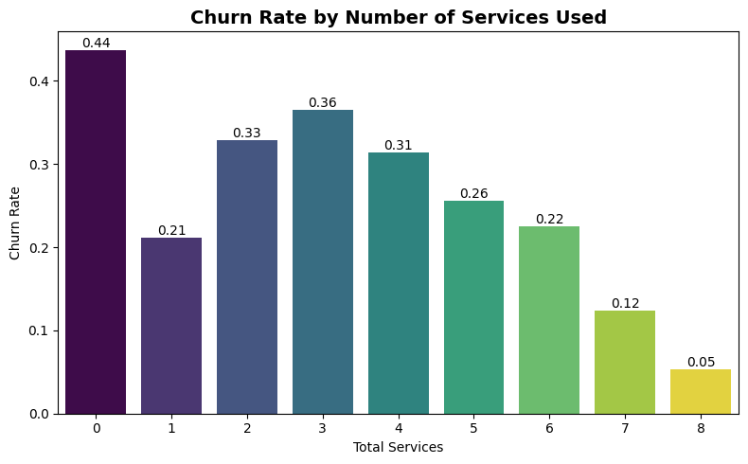
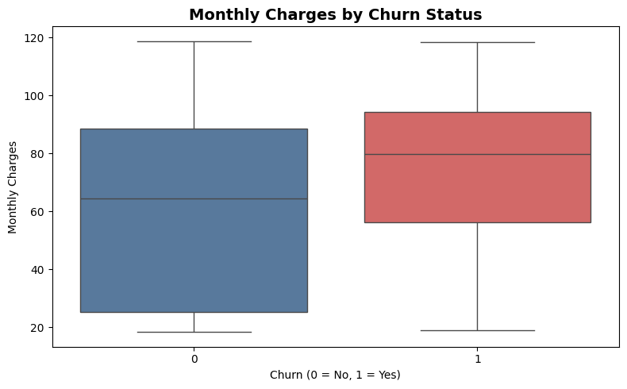
4. Model Development
4.1 Training and Testing Strategy
The prepared data was divided into 80% training data and 20% testing data. Stratified sampling was used so that the proportion of churned and non-churned customers remained similar in both subsets. The test set contained 1,409 records, including 374 churned customers and 1,035 non-churned customers.
A preprocessing pipeline was used to keep every transformation consistent between training and testing. Numerical features were median-imputed if needed and scaled with Min-Max normalization. Categorical features were imputed using their most frequent value and transformed using one-hot encoding. This pipeline approach prevents accidental use of test-set information during model training.
Code : -
X = df_model.drop(columns=["Churn"])
y = df_model["Churn"]
X_train, X_test, y_train, y_test = train_test_split(
X, y, test_size=0.20, random_state=42, stratify=y
)
preprocessor = ColumnTransformer(transformers=[
("num", numerical_transformer, numerical_features),
("cat", categorical_transformer, categorical_features)
])
4.2 Logistic Regression Baseline
Logistic Regression was selected as the baseline classifier because it is efficient, widely used for binary classification, and relatively easy to interpret. It estimates the probability that a customer belongs to the churn class. The model provided a strong benchmark against which the Decision Tree was compared.
Code : -
logistic_model = Pipeline(steps=[
("preprocessor", preprocessor),
("model", LogisticRegression(max_iter=1000, random_state=42))
])
logistic_model.fit(X_train, y_train)
logistic_predictions = logistic_model.predict(X_test)
logistic_probabilities = logistic_model.predict_proba(X_test)[:, 1]
4.3 Decision Tree Classifier
A Decision Tree Classifier was used as a second model because it can capture non-linear decision rules and identify feature importance. Depth and minimum-sample settings were used to reduce excessive overfitting, and class_weight='balanced' was used to give appropriate attention to the smaller churn class.
Code : -
decision_tree_model = Pipeline(steps=[
("preprocessor", preprocessor),
("model", DecisionTreeClassifier(
max_depth=5, min_samples_split=20, min_samples_leaf=10,
random_state=42, class_weight="balanced"
))
])
decision_tree_model.fit(X_train, y_train)
tree_predictions = decision_tree_model.predict(X_test)
tree_probabilities = decision_tree_model.predict_proba(X_test)[:, 1]
5. Model Evaluation Results
Both models were evaluated using accuracy, precision, recall, F1-score, and ROC-AUC. Accuracy reports the proportion of all correct predictions. Precision measures how often a predicted churn case truly churned. Recall measures how many actual churn cases the model identified. F1-score balances precision and recall. ROC-AUC measures how well a model separates churned and non-churned customers over possible thresholds.
Model | Accuracy | Precision | Recall | F1-score | ROC-AUC
Logistic Regression | 0.7991 | 0.6502 | 0.5267 | 0.5820 | 0.8412
Decision Tree | 0.7516 | 0.5220 | 0.7620 | 0.6196 | 0.8353
5.1 Logistic Regression Interpretation
Logistic Regression achieved the highest accuracy (79.91%), precision (65.02%), and ROC-AUC (0.8412). This indicates that it was the stronger model for overall correct classification and for distinguishing between churned and non-churned customers across thresholds. However, recall for churned customers was 52.67%, meaning that it identified only around half of the actual churn cases. This is a limitation when the business objective is to intervene before customers leave.
5.2 Decision Tree Interpretation
The Decision Tree achieved lower accuracy (75.16%) and precision (52.20%), but its churn recall was 76.20% and its F1-score was 61.96%. The model therefore identified approximately 285 of the 374 actual churn customers in the test set, compared with approximately 197 identified by Logistic Regression. It misses fewer potential churners, but produces more false-positive alerts. This trade-off is appropriate when the cost of missing a churn-risk customer is greater than the cost of offering a retention action to a customer who would not otherwise churn.
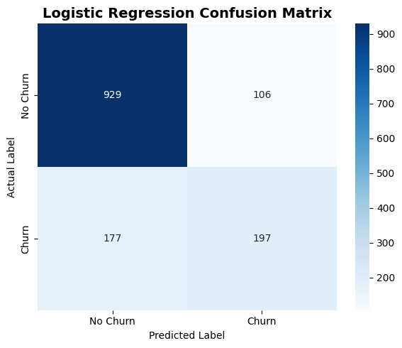
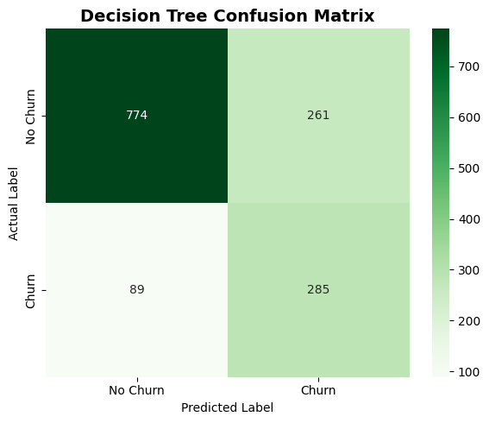

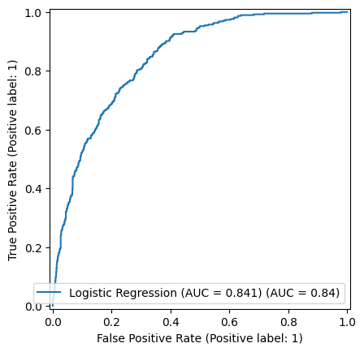
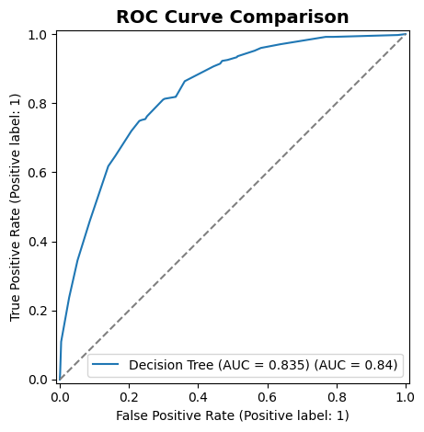

6. Feature Importance and Key Findings
Feature importance was calculated from the Decision Tree. An importance value shows how useful a feature was for splitting records within this trained model. It does not indicate a causal effect or whether the association is positive or negative by itself.
Rank | Feature | Importance score | Interpretation
1 | IsMonthToMonth | 0.6049 | Contract flexibility was the strongest predictive signal in this tree.
2 | tenure | 0.1167 | Customer relationship length was an important churn pattern.
3 | InternetService_Fiber optic | 0.1074 | Fibre-optic service category was highly useful for separating outcomes.
4 | MonthlyCharges | 0.0365 | Monthly bill size contributed to churn prediction.
5 | TotalCharges | 0.0210 | Cumulative charges provided additional customer-history information.
6 | TechSupport_No | 0.0193 | Lack of technical support added predictive value.
7 | AvgMonthlySpend | 0.0189 | Engineered spending behaviour added predictive value.
8 | Contract_Two year | 0.0170 | Longer contract category contributed to the model's decisions.
9 | OnlineSecurity_No | 0.0126 | Absence of online security contributed modestly.
10 | PaymentMethod_Electronic check | 0.0108 | Payment method contributed modestly.
The clearest finding is that contract type, especially month-to-month status, was more useful than any other individual feature in this Decision Tree. Tenure and fibre-optic internet service were the next most informative variables. These findings suggest that customer-retention efforts could focus on newly acquired or flexible-contract customers, while further business investigation should explore service quality, pricing, support availability, and payment preferences.

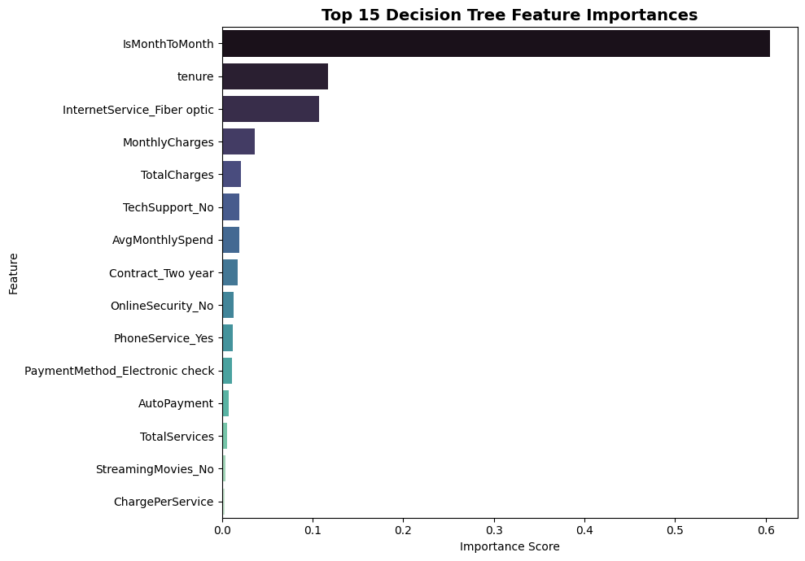
7. Model Selection
Logistic Regression is the stronger model when the priority is overall accuracy, fewer false positives, and a slightly higher ROC-AUC. The Decision Tree is the stronger model when the priority is to identify as many churn-risk customers as possible. Because the project objective is customer churn prediction and early retention action, the Decision Tree is selected as the recommended operational model.
This selection does not mean the Decision Tree is universally superior. The appropriate model depends on the business cost of false positives and false negatives. For example, a costly retention campaign may prefer the higher precision of Logistic Regression, while a low-cost email or support outreach campaign may prioritize the higher recall of the Decision Tree.
8. Limitations and Potential Improvements
Tune hyperparameters using GridSearchCV or RandomizedSearchCV rather than relying on a single manually selected Decision Tree configuration.
Use cross-validation to evaluate performance across several training/testing folds.
Experiment with Random Forest, Gradient Boosting, or XGBoost if permitted by the internship guidelines.
Tune the decision threshold for Logistic Regression to improve churn recall while monitoring precision.
Study class imbalance using class weights, SMOTE, or other resampling methods, only within the training data.
Assess model fairness and business impact before using predictions for real customer decisions.
Collect additional customer-satisfaction, complaint, service-outage, and support-interaction information, which may explain churn beyond the current variables.
9. Conclusion
This Week 3 task successfully applied feature engineering and machine learning classification to the Telco Customer Churn dataset. The final workflow created seven customer-focused features, prepared the data through a reproducible preprocessing pipeline, and compared Logistic Regression with a Decision Tree Classifier.
Logistic Regression provided the strongest overall accuracy and ROC-AUC, while the Decision Tree provided substantially higher churn recall and a better churn-class F1-score. The Decision Tree was selected for the churn-retention use case because it identifies more customers who are likely to leave. The feature-importance analysis highlighted month-to-month contracts, tenure, and fibre-optic service as the most useful signals for this model. Future work can improve robustness using cross-validation, hyperparameter tuning, threshold optimisation, and ensemble methods.
Appendix A. Key Evaluation Code
Code : -
def evaluate_model(y_true, predictions, probabilities, name):
print(name)
print("Accuracy: ", accuracy_score(y_true, predictions))
print("Precision:", precision_score(y_true, predictions))
print("Recall: ", recall_score(y_true, predictions))
print("F1-score: ", f1_score(y_true, predictions))
print("ROC-AUC: ", roc_auc_score(y_true, probabilities))
print(classification_report(y_true, predictions))
model_results = pd.DataFrame({
"Model": ["Logistic Regression", "Decision Tree"],
"Accuracy": [logistic_accuracy, tree_accuracy],
"Precision": [logistic_precision, tree_precision],
"Recall": [logistic_recall, tree_recall],
"F1-Score": [logistic_f1, tree_f1],
"ROC-AUC": [logistic_auc, tree_auc]
})
display(model_results.sort_values(by="ROC-AUC", ascending=False))

Appendix B. Visualization Code Snippets
B.1 Churn distribution
Code : -
plt.figure(figsize=(7, 5))
ax = sns.countplot(data=df_model, x="Churn", hue="Churn",
palette=["#4C78A8", "#E45756"], legend=False)
plt.title("Distribution of Customer Churn")
plt.xlabel("Churn (0 = No, 1 = Yes)")
plt.ylabel("Number of Customers")
for container in ax.containers:
ax.bar_label(container)
plt.tight_layout()
plt.savefig("week3_graphs/churn_distribution.png", dpi=300)
plt.show()

B.2 Confusion matrix
Code : -
cm = confusion_matrix(y_test, tree_predictions)
plt.figure(figsize=(6, 5))
sns.heatmap(cm, annot=True, fmt="d", cmap="Greens",
xticklabels=["No Churn", "Churn"],
yticklabels=["No Churn", "Churn"])
plt.title("Decision Tree Confusion Matrix")
plt.xlabel("Predicted Label")
plt.ylabel("Actual Label")
plt.tight_layout()
plt.savefig("week3_graphs/decision_tree_confusion_matrix.png", dpi=300)
plt.show()

B.3 ROC curve
Code : -
plt.figure(figsize=(8, 6))
RocCurveDisplay.from_predictions(
y_test, logistic_probabilities,
name=f"Logistic Regression (AUC = {logistic_auc:.3f})"
)
RocCurveDisplay.from_predictions(
y_test, tree_probabilities,
name=f"Decision Tree (AUC = {tree_auc:.3f})"
)
plt.plot([0, 1], [0, 1], linestyle="--", color="gray")
plt.title("ROC Curve Comparison")
plt.tight_layout()
plt.savefig("week3_graphs/roc_curve_comparison.png", dpi=300)
plt.show()
B.4 Feature-importance chart
Code : -
top_features = feature_importance.sort_values(
by="Importance", ascending=False
).head(15)
plt.figure(figsize=(10, 7))
sns.barplot(data=top_features, x="Importance", y="Feature",
hue="Feature", palette="mako", legend=False)
plt.title("Top 15 Decision Tree Feature Importances")
plt.xlabel("Importance Score")
plt.ylabel("Feature")
plt.tight_layout()
plt.savefig("week3_graphs/feature_importance.png", dpi=300)
plt.show()

